QUIET PLEASE

**QUIET PLEASE**

QUIET PLEASE

**QUIET PLEASE**

QUIET PLEASE

**QUIET PLEASE**

QUIET PLEASE

**QUIET PLEASE**

QUIET PLEASE

**QUIET PLEASE**

QUIET PLEASE

**QUIET PLEASE**

QUIET PLEASE

**QUIET PLEASE**

QUIET PLEASE

**QUIET PLEASE**

QUIET PLEASE

**QUIET PLEASE**

QUIET PLEASE

**QUIET PLEASE**

QUIET PLEASE

**QUIET PLEASE**

QUIET PLEASE **QUIET PLEASE**

DO CLOSE THE DOOR SOFTLY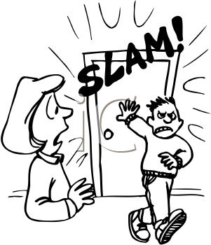

DO CLOSE THE DOOR SOFTLY